**EXPERIMENT -3**

1. **Create the tables for** Company database as per ER diagram of Exp 2.
2. **Insert the following data into their respective tables of Company database.**

Akshat Srivastava

Batch 2

500123177

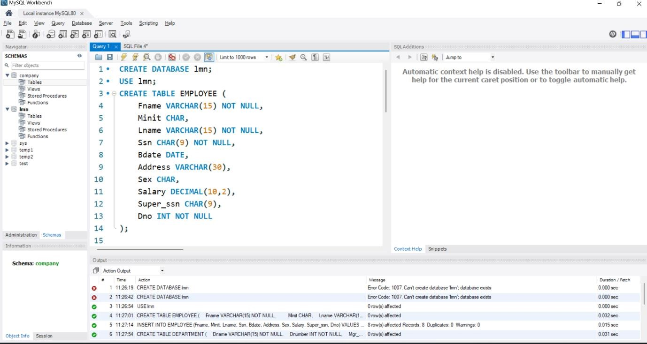

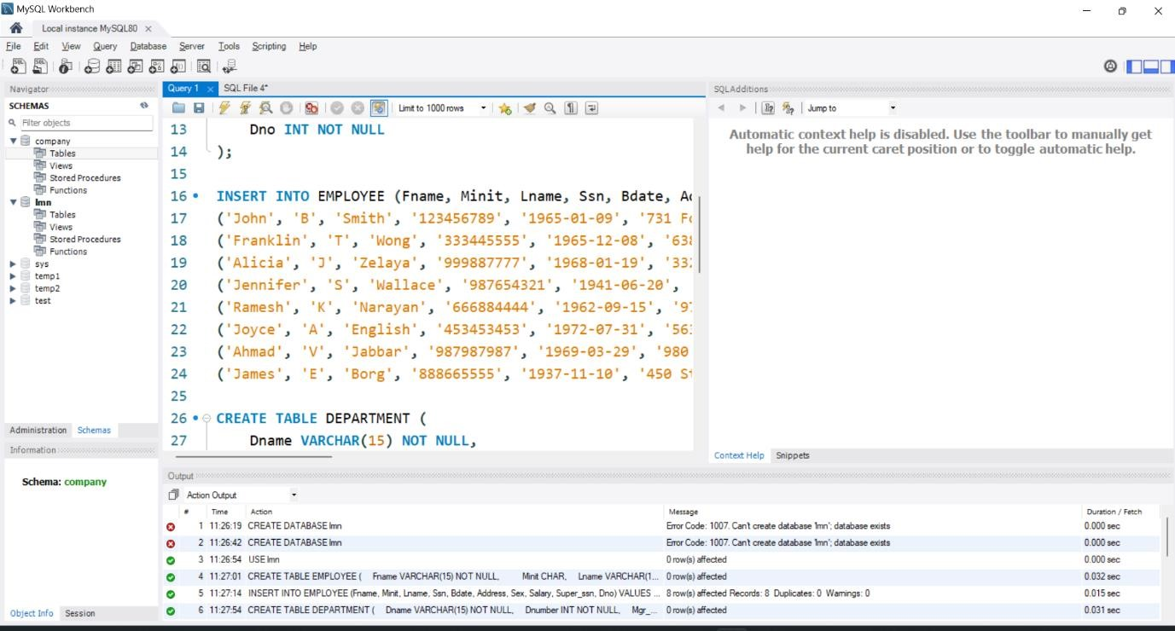

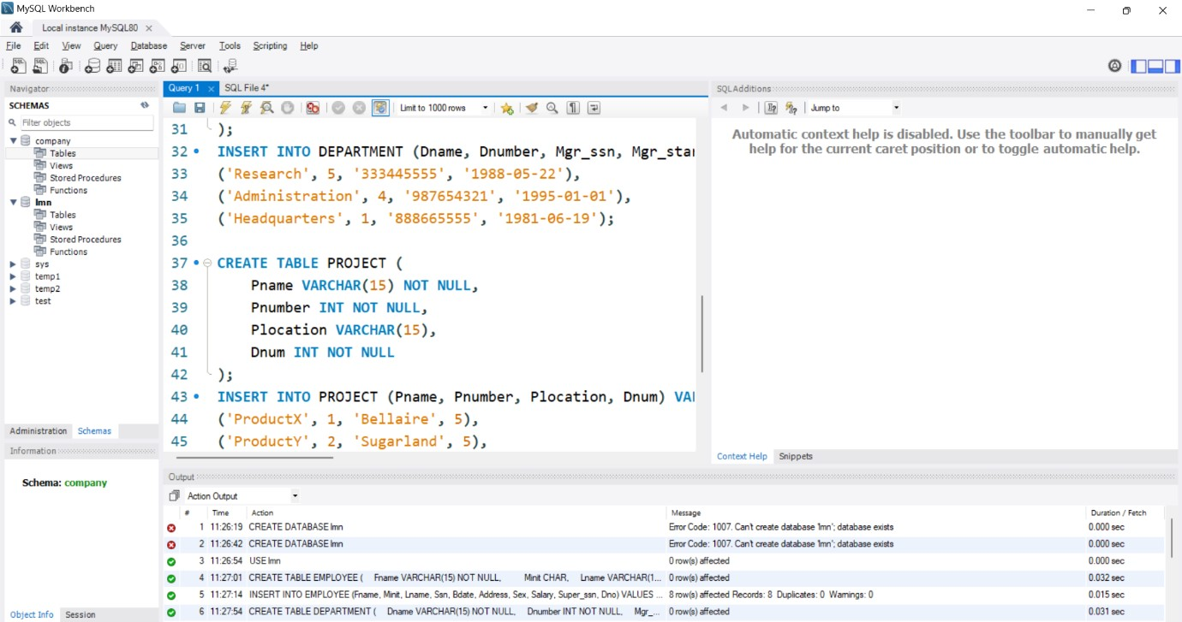

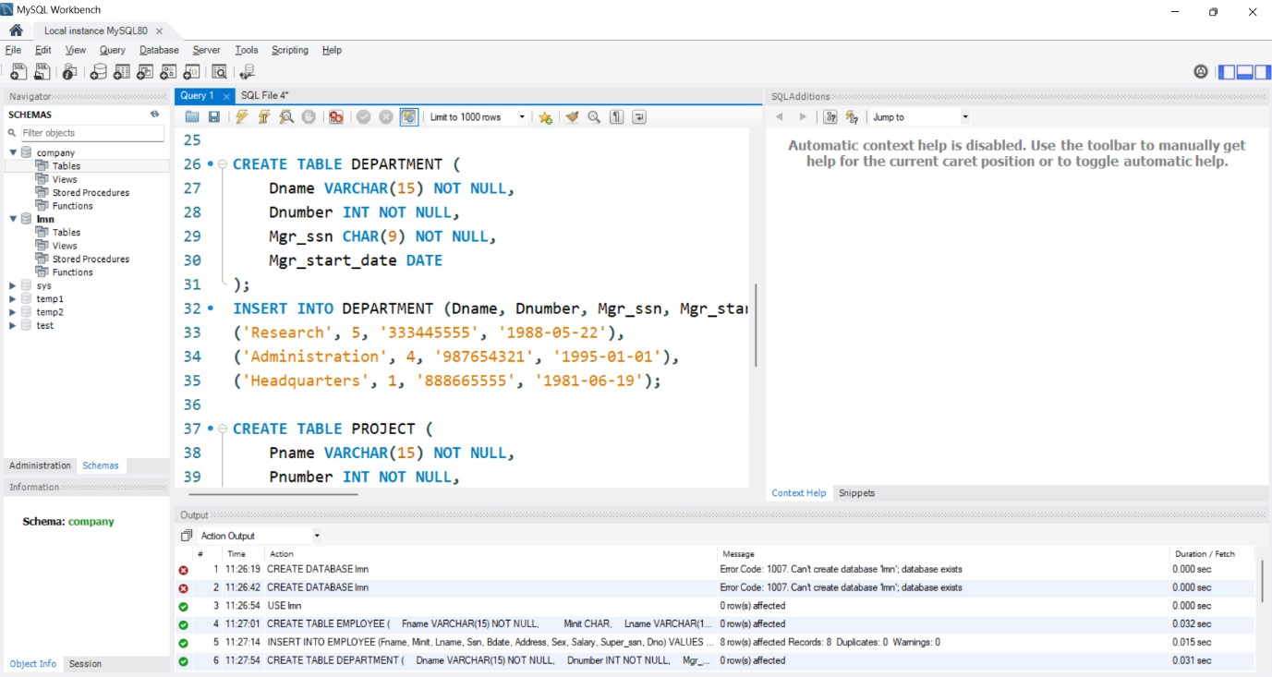

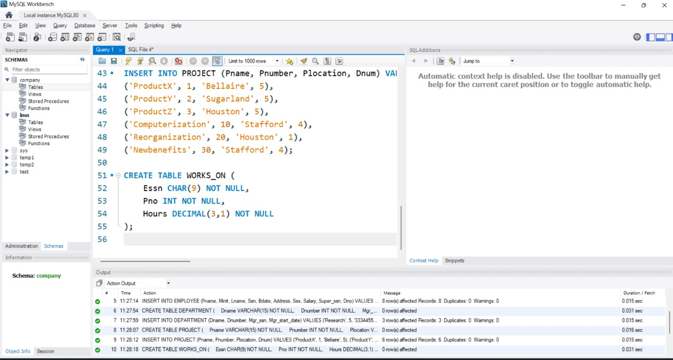

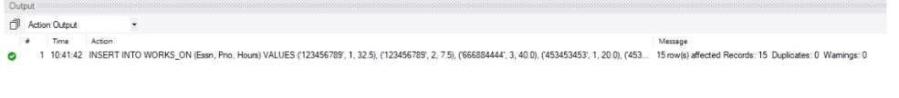

Outputs –

